Magnitude of a Vector
(a) | (b) | (c)
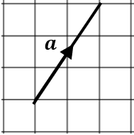  Find the magnitude of vector $a$to 1 decimal place. | 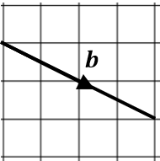  Find the magnitude of vector $b$, leaving your answer as a surd. | $c=\left(\begin{matrix}5 \\ 1\end{matrix}\right)$. Draw the vector $c$ and find its magnitude to 1 decimal place.
(d) |  | (e) | (f)
$d=\left(\begin{matrix}-4 \\ 5\end{matrix}\right)$. Draw the vector $d$ and find its magnitude, leaving your answer in surd form. |  | Find the magnitude of the vector $\left(\begin{matrix}8 \\ -6\end{matrix}\right)$ | Find the magnitude of the vector $\left(\begin{matrix}-7 \\ 2.5\end{matrix}\right)$, giving your answer to 1 decimal place.
(g) | (h) | (i) | (j)
Find the magnitude of the vector $\left(\begin{matrix}5 \\ \sqrt{3}\end{matrix}\right)$, giving your answer as a simplified surd. | $$a=\left(\begin{matrix}6 \\ -2\end{matrix}\right) b=\left(\begin{matrix}-1 \\ 14\end{matrix}\right)$$  Find the magnitude of the vector $a+b$. | $$a=\left(\begin{matrix}-3 \\ 5\end{matrix}\right) b=\left(\begin{matrix}-1 \\ -2\end{matrix}\right)$$  Find the magnitude of the vector $a-3b$. | Find as many vectors as you can with the same magnitude as the vector $\left(\begin{matrix}2 \\ -1\end{matrix}\right)$.

