Area of a Circle
(a) | (b) | (c) | (d)
Find the radius of a circle when the diameter is $5$ cm | Find the radius of a circle when the diameter is $8.2$ m | Find the diameter of a circle when the radius is $47$ mm | Find the diameter of a circle when the radius is $0.7$ m
(e) | (f) | (g) | (h)
Find the area of a circle with a radius of $6$ cm | Find the area of a circle with a radius of $80$ mm | Find the area of a circle with a radius of $3.5$ m | Find the area of a circle with a radius of $13.5$ cm
(i) | (j) | (k) | (l)
Find the area of a circle with a diameter of $30$ mm | Find the area of a circle with a diameter of $1.8$ m | Find the area of a circle with a diameter of $26$ mm | Find the area of a circle with a diameter of $45$ cm
(m) | (n) | (o) | (p)
Find the area of the circle shown to 1 decimal place.  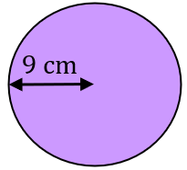 | Find the area of the circle shown to 1 decimal place.  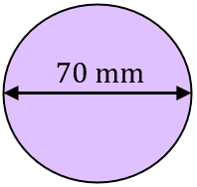 | Find the area of the circle shown to 1 decimal place.  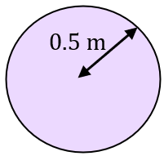 | Find the area of the circle shown to 1 decimal place.  