Volume of Cylinders, Cones and Spheres
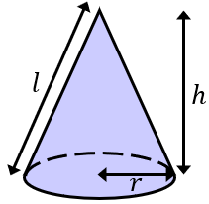  $$Volume of Cone=\frac{1}{3}πr^{2}h$$ | 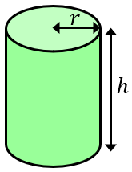  $$Volume of Cylinder=πr^{2}h$$ |  | 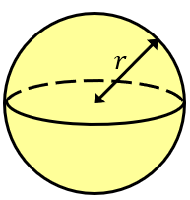  $$Volume of Sphere=\frac{4}{3}πr^{3}$$
(a) | (b) |  | (c)
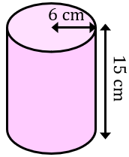  Find the volume, giving your answer in terms of $π$ | 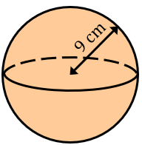  Find the volume, giving your answer to the nearest cm³ |  | 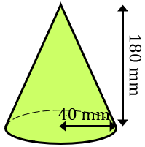  Find the volume, giving your answer to 3 significant figures
(d) | (e) |  | (f)
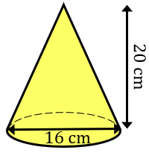  Find the volume, giving your answer to 3 significant figures | 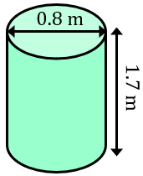  Find the volume, giving your answer to 2 decimal places |  | 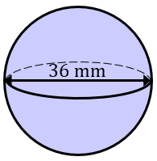  Find the volume, leaving your answer in terms of $π$
(g) | (h) |  | (i)
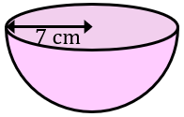  Find the volume of the hemisphere to the nearest cm³ | 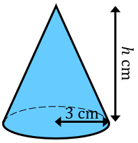  The cone has a volume of $39π {cm}^{3}$. Find the height $h$. |  | 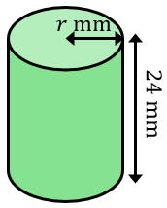  The cylinder has a volume of $6100 {mm}^{2}.$Find its radius to the nearest mm.
(j) |  | (k)
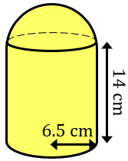  A shape is made by joining a hemisphere to a cylinder. Both have a radius of $6.5 cm$. Find the total volume of the shape. |  | 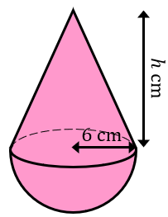  A shape is made by joining a cone to a hemisphere, where both shapes have the same radius. The total volume is $402π {cm}^{3}$. Find the height of the cone.

