Which Trigonometry Ratio?
Label each of the triangles with opposite (O), adjacent (A) and hypotenuse (H). Use this to decide which ratio to use – sin (SOH), cos (CAH) or tan (TOA).
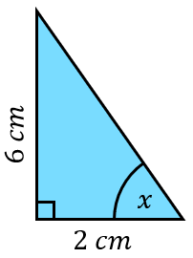
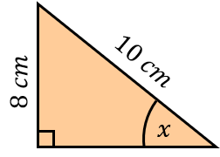
(a) (b)

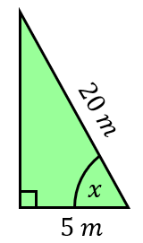
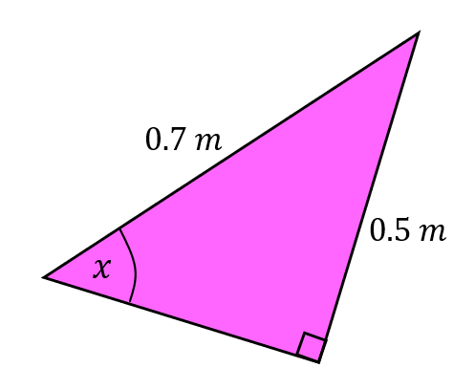
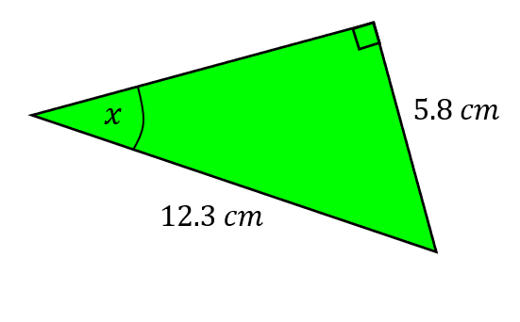
(c) (d)
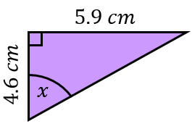

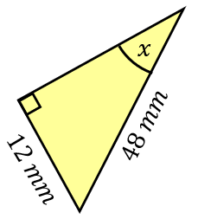
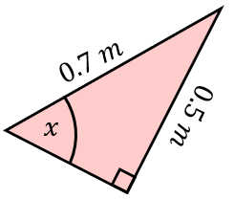
(e) (f)

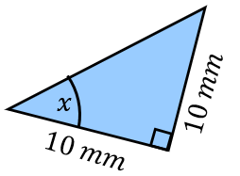
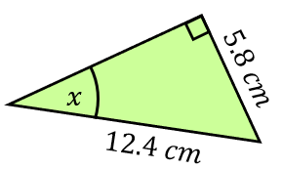
(g) (h)

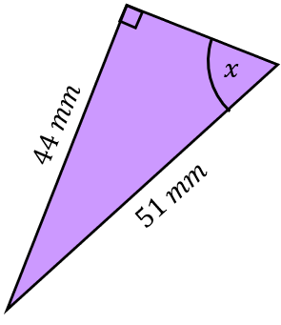
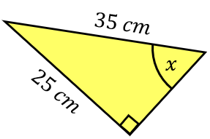
(i) (j)

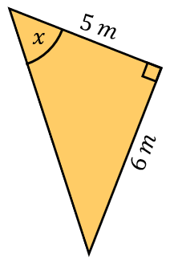
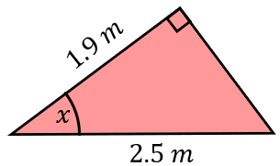
(k) (l)

Which Trigonometry Ratio?
Label each of the triangles with opposite (O), adjacent (A) and hypotenuse (H). Use this to decide which ratio to use – sin (SOH), cos (CAH) or tan (TOA).
(a) (b)

(c) (d)

(e) (f)

(g) (h)

(i) (j)

(k) (l)

