Fill In The Blanks…
Dividing Algebraic Fractions

Question | Write as a Multiplication | Simplify Numerator and Denominator | Simplified Answer  (where possible)
$$\frac{x}{4}÷\frac{x}{2y}$$ | $$\frac{x}{4}×\frac{2y}{x}$$ | $$\frac{2xy}{4x}$$ | $$\frac{y}{2}$$
$$\frac{3x}{y}÷\frac{1}{xy}$$ | $$\frac{3x}{y}×\frac{xy}{1}$$ | $$\frac{3x^{2}y}{y}$$
$$\frac{2y}{3}÷\frac{4}{y}$$ | $$\frac{2y}{3}×\frac{y}{4}$$
$$\frac{xy}{5}÷\frac{3y}{10}$$
$$\frac{4y}{3x}÷\frac{xy}{6}$$
$$\frac{x^{2}}{8}÷\frac{3x}{4y}$$
$$\frac{6xy}{5}÷\frac{x}{y}$$
$$\frac{5x}{3}÷\frac{10}{xy}$$
$$\frac{2x}{y}÷\frac{4xy}{9}$$
$$\frac{4}{5xy}÷\frac{2y^{2}}{x^{2}}$$
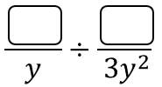 | 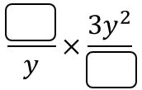 | $$\frac{6xy^{2}}{8y}$$
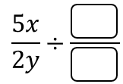 |  |  | $$10y$$

