Plotting Frequency Polygons
(a) | (b)
The table shows the speeds of 60 motorbikes on a road.  Speed $s$ (mph) Frequency  $$0<s≤10$$ $$3$$  $$10<s≤20$$ $$11$$  $$20<s≤30$$ $$24$$  $$30<s≤40$$ $$15$$  $$40<s≤50$$ $$7$$ | The table shows the number of pairs of shoes owned by 50 students.  Number of Pairs of Shoes Frequency  $$1-3$$ $$6$$  $$4-6$$ $$16$$  $$7-9$$ $$18$$  $$10-12$$ $$7$$  $$13-15$$ $$3$$
Draw a frequency polygon to represent this information.  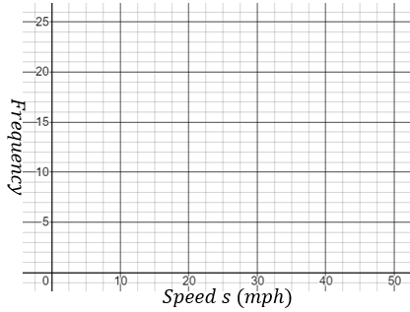 | Draw a frequency polygon to represent this information.  