Translating Shapes
(a) | (b) | (c)
Translate the shape 3 units to the right.  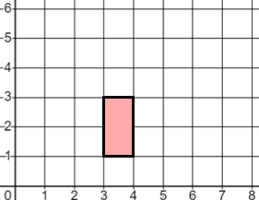 | Translate the shape 4 units right and 1 unit up.  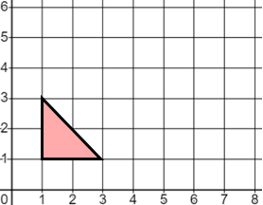 | Translate the shape 3 units left and 2 units down.  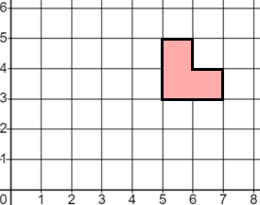
(d) | (e) | (f)
Translate the shape by $\left(\begin{matrix}4 \\ 2\end{matrix}\right)$  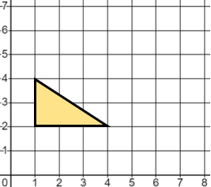 | Translate the shape by $\left(\begin{matrix}3 \\ 1\end{matrix}\right)$  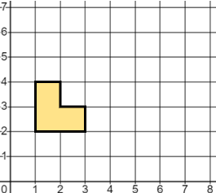 | Translate the shape by $\left(\begin{matrix}-2 \\ 2\end{matrix}\right)$  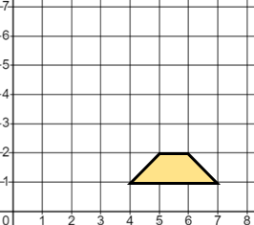
(g) | (h) | (i)
Translate the shape by $\left(\begin{matrix}4 \\ -1\end{matrix}\right)$  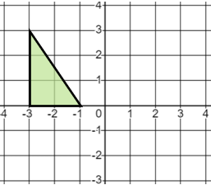 | Translate the shape by $\left(\begin{matrix}-1 \\ 3\end{matrix}\right)$  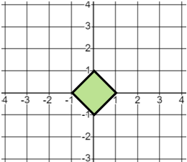 | Translate the shape by $\left(\begin{matrix}2 \\ -3\end{matrix}\right)$  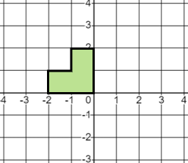
(j) | (k) | (l)
Translate the shape by $\left(\begin{matrix}-2 \\ -4\end{matrix}\right)$  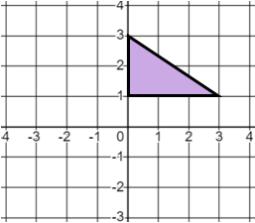 | Translate the shape by $\left(\begin{matrix}-5 \\ -1\end{matrix}\right)$  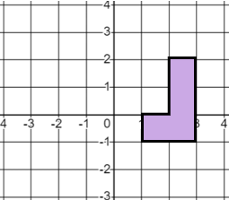 | Translate the shape by $\left(\begin{matrix}0.5 \\ -3\end{matrix}\right)$  