Origami Swan
To make this swan you will need a 15 cm square of origami paper.
Step 1 – Fold your square point to point to make a diagonal fold.  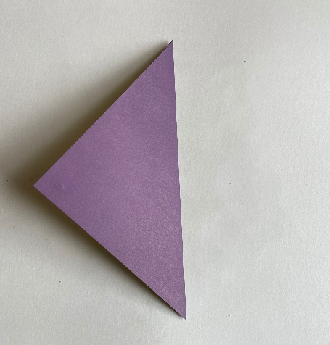 | Step 2 – Unfold to open the paper back out.  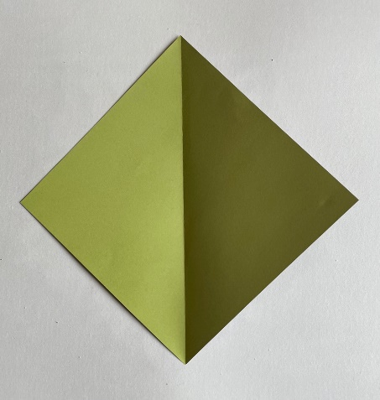 | Step 3 – Fold the right-hand edge in to meet the vertical fold.  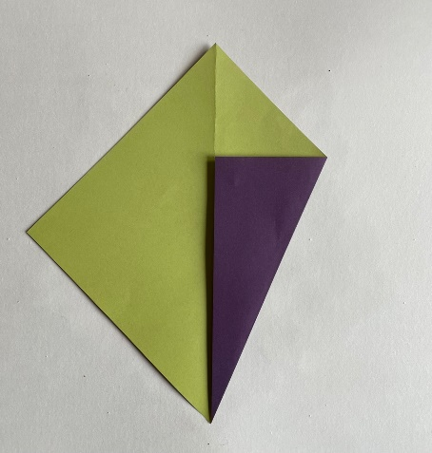
Step 4 – Fold the left-hand edge in to meet the vertical fold.  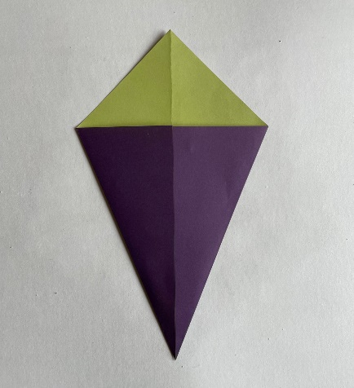 | Step 5 – Turn the kite shape over.  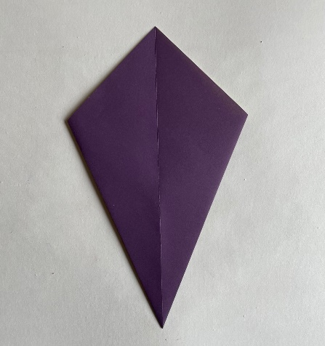 | Step 6 – Fold the right-hand edge in to meet the vertical fold.  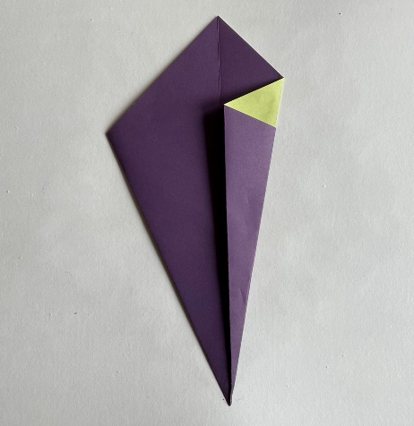
Step 7 – Repeat on the left-hand side to make a narrow kite.  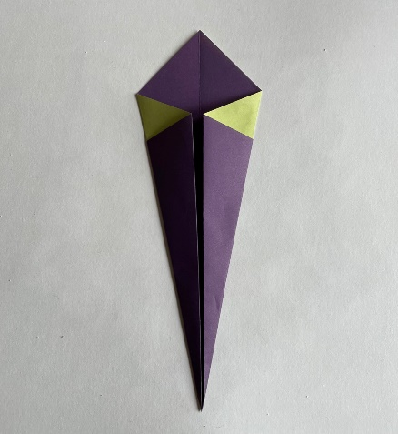 | Step 8 - Fold in half to make the neck, by folding the bottom point to meet the top point.  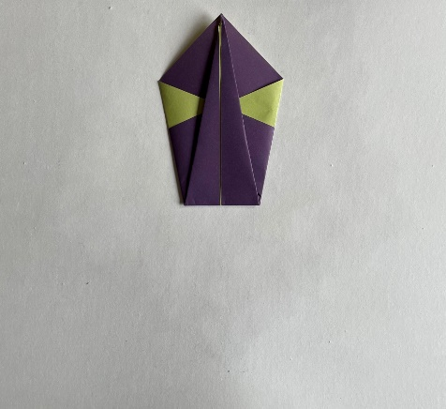 | Step 9 – Fold back down around one third of the way to make the swan’s head.  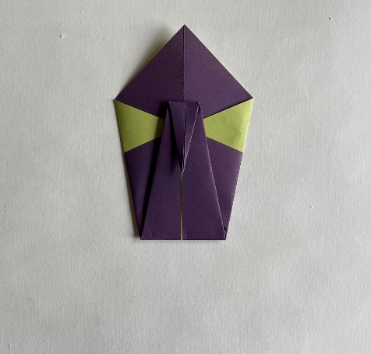
Step 10 – Fold in half vertically away from you, and then rotate through 90º.  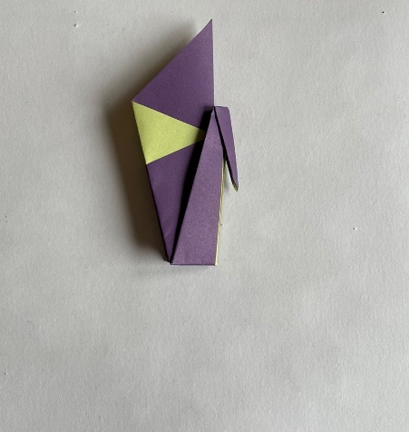 | Step 11 – Pull up the neck to make an acute angle, pinch at the bottom left to hold it in place.  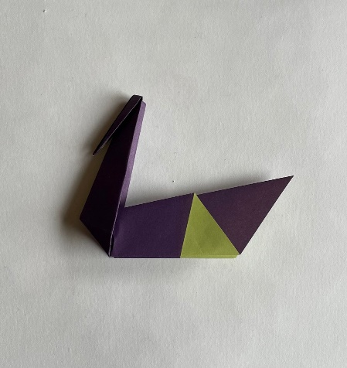 | Step 12 – Pull up the head to a suitable angle, pinch at the top of the head to hold it in place.  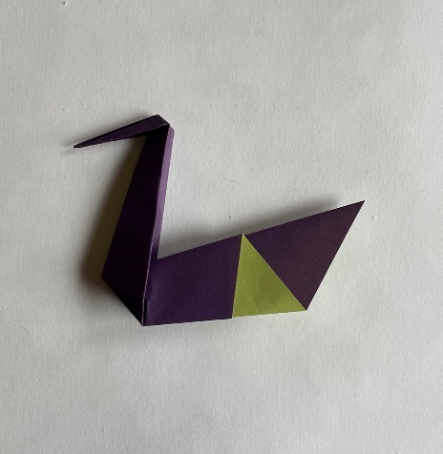
Step 13 – You now have a lovely origami swan!

