Probability and Two Set Venns
The Venn diagram shows information of 150 patients in a local surgery. They were asked if they took any medication for cholesterol (C) or blood pressure (B).
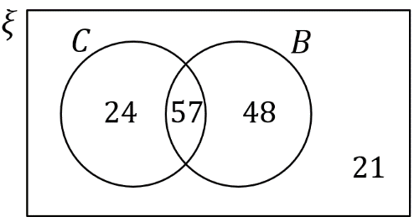

A patient is chosen at random.
(a) Work out the probability that a patient took neither medication.
(b) Work out the probability that a patient took cholesterol not but blood pressure medication.
(c) Given that the patient took blood pressure medication, what is the probability that they also took cholesterol medication?

90 people in a sports club were surveyed. 19 play tennis and squash. 50 play tennis. 32 play squash.
(a) Represent this with a Venn diagram.
One person is chosen at random.
(b) Work out the probability that the person chosen does not play tennis
(c) Work out the probability that the person chosen plays tennis or squash or both.
(d) Given that the person plays tennis, work out the probability that they also play squash.

In a group of 40 children there are 19 who can swim and 16 who can ride a bike.
There are 5 children who can swim and ride a bike.
(a) Draw a Venn diagram.
A child is selected at random.
(b) Find the probability that this child cannot swim or ride a bike.
Another child is selected at random.
(c) Given that this child can ride a bike, work out the probability that this child can swim.
Probability and Two Set Venns
The Venn diagram shows information of 150 patients in a local surgery. They were asked if they took any medication for cholesterol (C) or blood pressure (B).

A patient is chosen at random.
(a) Work out the probability that a patient took neither medication.
(b) Work out the probability that a patient took cholesterol not but blood pressure medication.
(c) Given that the patient took blood pressure medication, what is the probability that they also took cholesterol medication?

90 people in a sports club were surveyed. 19 play tennis and squash. 50 play tennis. 32 play squash.
(a) Represent this with a Venn diagram.
One person is chosen at random.
(b) Work out the probability that the person chosen does not play tennis
(c) Work out the probability that the person chosen plays tennis or squash or both.
(d) Given that the person plays tennis, work out the probability that they also play squash.

In a group of 40 children there are 19 who can swim and 16 who can ride a bike.
There are 5 children who can swim and ride a bike.
(a) Draw a Venn diagram.
A child is selected at random.
(b) Find the probability that this child cannot swim or ride a bike.
Another child is selected at random.
(c) Given that this child can ride a bike, work out the probability that this child can swim.

