Surds with Perimeter, Area, Volume
Find the area and perimeter of these rectangles.
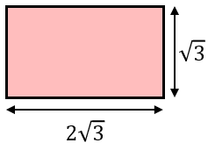
(a)

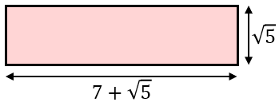
(b)

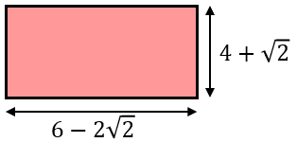
(c)

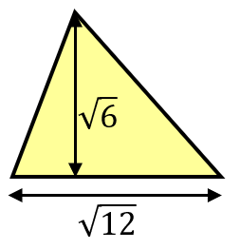
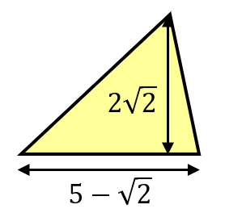
Find the area of these triangles.
(a) (b)

The perimeter of this rectangle is $8\sqrt{2}$. Find the area of the rectangle.

(a) The volume of the cuboid shown is $15+5\sqrt{3}$. Find the height of the cuboid.
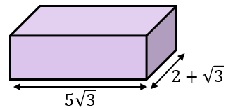

(b) The volume of a cylinder is $40π+20π\sqrt{2}$. If the height of the cylinder is $2+\sqrt{2}$, find the exact radius of the cylinder.
Surds with Perimeter, Area, Volume
Find the area and perimeter of these rectangles.
(a)

(b)

(c)

Find the area of these triangles.
(a) (b)

The perimeter of this rectangle is $8\sqrt{2}$. Find the area of the rectangle.

(a) The volume of the cuboid shown is $15+5\sqrt{3}$. Find the height of the cuboid.

(b) The volume of a cylinder is $40π+20π\sqrt{2}$. If the height of the cylinder is $2+\sqrt{2}$, find the exact radius of the cylinder

