Representing Double Inequalities
(a) | (b) | (c) | (d)
Write down all the integers that satisfy the inequality  $$2≤x≤5$$ | Write down all the integers that satisfy the inequality  $$1<x≤4$$ | Write down all the integers that satisfy the inequality  $$-1≤x<3$$ | Write down all the integers that satisfy the inequality  $$-4<x<1$$
(e) | (f) | (g) | (h)
Write down the inequality shown.  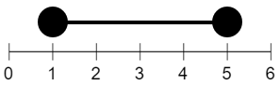 | Write down the inequality shown.  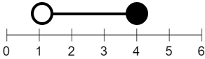 | Write down the inequality shown.  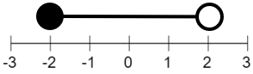 | Write down the inequality shown.  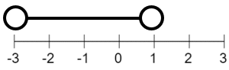
(i) | (j) | (k) | (l)
Show the inequality  $$1<x<6$$  on the number line.  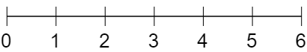 | Show the inequality  $$0≤x<3$$  on the number line. | Show the inequality  $$1≤x≤3$$  on the number line. | Show the inequality  $$2<x≤5$$  on the number line.
(m) | (n) | (o) | (p)
Show the inequality  $$-1≤x≤3$$  on the number line.  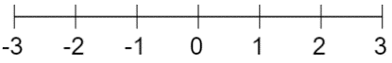 | Show the inequality  $$-3≤x<0$$  on the number line. | Show the inequality  $$-2<x<2$$  on the number line. | Show the inequality  $$-1<x≤1$$  on the number line.

