Vectors and Midpoints
(a) |  | (b)
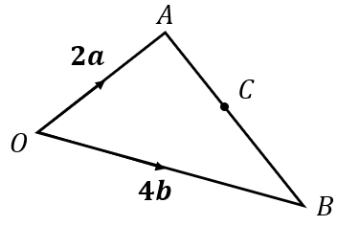  In the triangle $OAB$, $\vec{OA}=2a$ and $\vec{OB}=4b$. $C$ is the midpoint of the line $AB$.  Express the following in terms of $a$and $b$: |  | 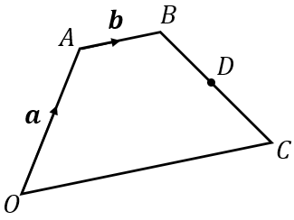  $OABC$ is a trapezium, where $\vec{OA}=a$ and $\vec{AB}=b$. $D$ is the midpoint of $BC$ and $\vec{OC}=2\vec{AB}$.  Express the following in terms of $a$and $b$:
(a) $\vec{AB}$ | (b) $\vec{BA}$ | (a) $\vec{OC}$ | (b) $\vec{CB}$
(c) $\vec{AC}$ | (d) $\vec{BC}$ | (c) $\vec{BC}$ | (d) $\vec{BD}$
(e) $\vec{OC}$ | (f) $\vec{CO}$ | (e) $\vec{AD}$ | (f) $\vec{DO}$
(c) |  | (d)
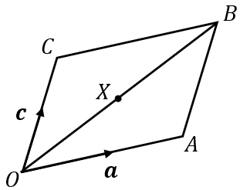  In the parallelogram $OABC$, $\vec{OA}=a$ and $\vec{OC}=c$.  $X$ is the midpoint of the line $OB$.  Express the following in terms of $a$and $c$: |  | 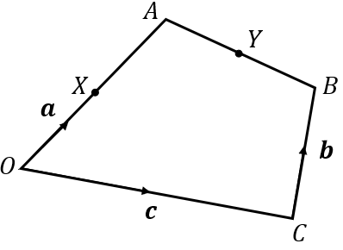  $OABC$ is a quadrilateral.  $\vec{OX}=a,$ $\vec{OC}=c$ and $\vec{CB}=b$.  $X$ is the midpoint of $OA$ and $Y$ is the midpoint of $AB$.  Express the following in terms of $a, b$and $c$:
(a) $\vec{CB}$ | (b) $\vec{BA}$ | (a) $\vec{OA}$ | (b) $\vec{OB}$
(c) $\vec{OB}$ | (d) $\vec{XB}$ | (c) $\vec{CA}$ | (d) $\vec{AB}$
(e) $\vec{XC}$ | (f) $\vec{AX}$ | (e) $\vec{AY}$ | (f) $\vec{XY}$
What do the answers to (e) and (f) tell us about the points $C, X$ and $A$? |  | What do the answers to (b) and (f) tell us about vectors $\vec{OB}$ and $\vec{XY}$?

