Match-Up
Trigonometry Worded Problems

1 | A ladder is placed $1.5 m$ from the foot of a wall. The ladder reaches $3.8 m$ vertically up the wall. Find the angle between the ground and the ladder in degrees. |  | A | $$13.0$$
2 | A plane-spotter sees a plane in the sky at an angle of elevation of $18°$. The plane is a horizontal distance of $40 km$ from the plane-spotter. Find the vertical height of the plane in kilometres. |  | B | $$134.7$$
3 | A bird sits on the ground $9 m$ away from the base of a Christmas tree. The angle of elevation from the bird to the top of the tree is $52°$. How tall is the tree in metres? |  | C | $$57.6$$
4 | A ship sails for $150 km$ on a bearing of $068°$. How far North has the ship sailed in kilometres? |  | D | $$68.5$$
5 | The angle of depression from the top of a $120 m$ cliff to a boat in the sea below is $63°$. What is the distance in $km$ from the top of the cliff to the boat? |  | E | $$12.6$$
6 | A ladder makes an angle of $75°$ with the ground. The distance of the foot of the ladder to the wall is $1.45 m$. How long is the ladder in metres? |  | F | $$11.5$$
7 | 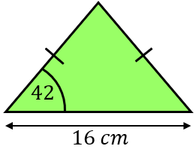  Find the area of this isosceles triangle in ${cm}^{2}$. |  | G | $$56.2$$
8 | Malia is flying a kite on a $20 m$ long string. The string is at an angle of $35°$ to the horizontal. Malia is holding the kite $1.1 m$ above the ground. Find the vertical height of the kite above the ground in metres. |  | H | $$5.6$$

1 | 2 | 3 | 4 | 5 | 6 | 7 | 8

