Fill In The Blanks…
Three-Step Functions

Input | Function Machine |  |  | Output | Function
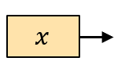 | 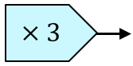 | 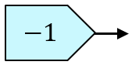 | 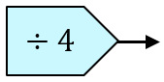 | 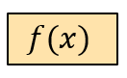 | $$f\left(x\right)=\frac{3x-1}{4}$$
 | 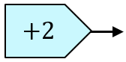 | 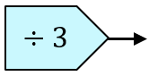 | 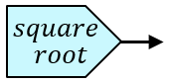
 | 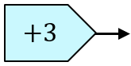 | 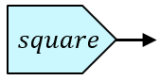 | 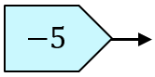 | 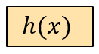
 |  | 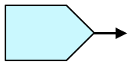 | 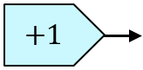 |  | $$f\left(x\right)=4\sqrt{x}+1$$
 | 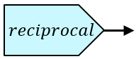 |  |  | 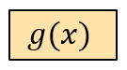 | $$g\left(x\right)=2\left(\frac{1}{x}-3\right)$$
 |  |  |  |  | $$f\left(x\right)=\frac{1}{3x}-1$$
 |  |  |  |  | $$f\left(x\right)={\left(\frac{x+2}{3}\right)}^{2}$$
 |  |  |  |  | $$g\left(x\right)=\frac{1}{4x-3}$$

