Cumulative Frequency Graphs
(a) |  | (b)
The heights of 40 oak trees are recorded in a frequency table.  (a) Use the information to calculate cumulative frequencies and plot a cumulative frequency graph.  (b) Use your cumulative frequency graph to find the median and interquartile range of the heights of the oak trees. | Height (m) Frequency  $$10<h≤15$$ 5  $$15<h≤20$$ 9  $$20<h≤25$$ 13  $$25<h≤30$$ 7  $$30<h≤35$$ 4  $$35<h≤40$$ 2 | The time taken by 100 students to complete a jigsaw is recorded in a grouped frequency table.  (a) Use the information to calculate cumulative frequencies and plot a cumulative frequency graph.  (c) Use your cumulative frequency graph to find the median and interquartile range of the times taken. | Time (minutes) Frequency  $$30<t≤40$$ 4  $$40<t≤50$$ 11  $$50<t≤60$$ 20  $$60<t≤70$$ 28  $$70<t≤80$$ 19  $$80<t≤90$$ 13  $$90<t≤100$$ 5
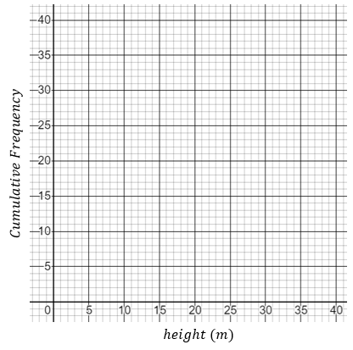
 |  | (c)
 |  | The History test score of 60 students is recorded in a grouped frequency table.  (a) Plot a cumulative frequency graph.  (b) Find the median score in the History test.  (c) Use you graph to estimate the number of students who scored less than 36 marks.  (d) Use your graph to find the minimum score required to come in the top 10% of students in the test. | Test Score Frequency  $$0<s≤10$$ 1  $$10<s≤20$$ 4  $$20<s≤30$$ 6  $$30<s≤40$$ 12  $$40<s≤50$$ 17  $$50<s≤60$$ 13  $$60<s≤70$$ 5  $$70<s≤80$$ 2

