Origami Butterfly
To make this butterfly you will need a 15 cm square of origami paper.
Step 1 – Fold the square in half horizontally. | Step 2 – Open the paper back up and rotate through 90º. | Step 3 –Fold the square in half horizontally again.
Step 4 – Open back up, then rotate through 45º.  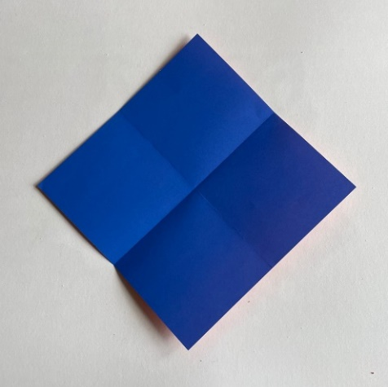 | Step 5 – Fold the bottom point up to the top point to make a diagonal fold.  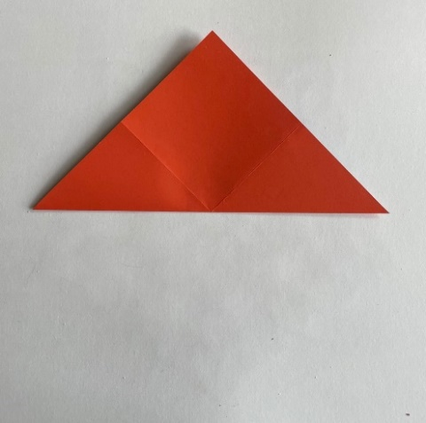 | Step 6 – Open back up, rotate through 90º and make the other diagonal fold.  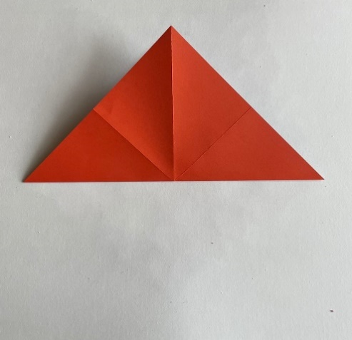
Step 7 – Open back up to reveal the four folds.  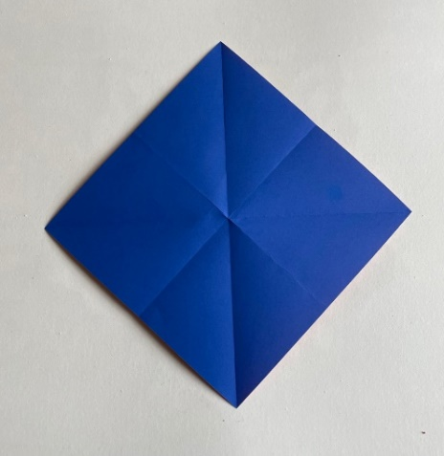 | Step 8 – Fold the bottom point up to meet the centre of the four folds.  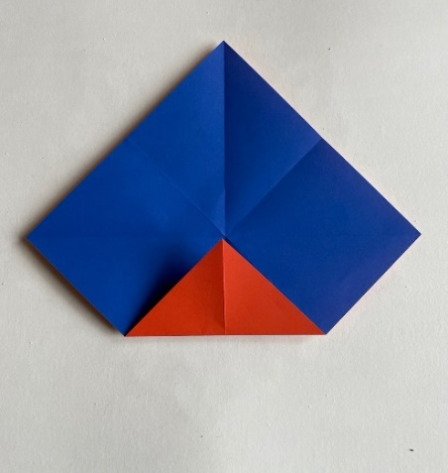 | Step 9 – Repeat with the other three points so that you have a square.  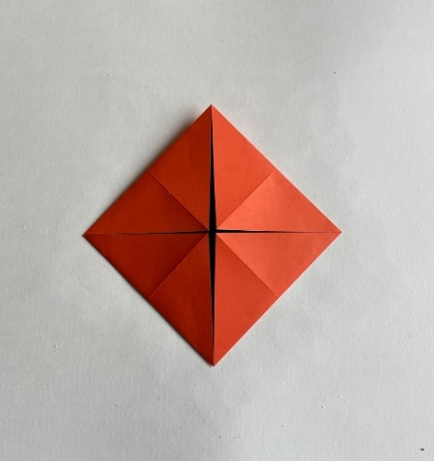
Step 10 – Turn over. Fold the bottom point up to the centre, where the folds meet.  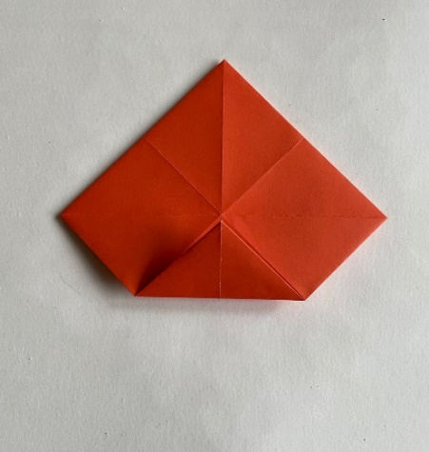 | Step 11 – Repeat with the other three points so that you have a smaller square.  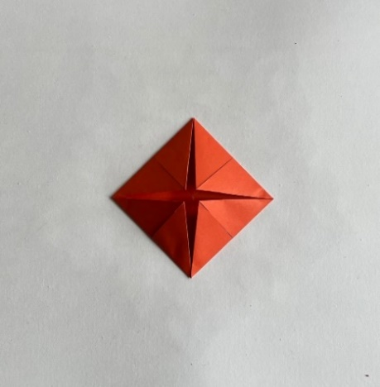 | Step 12 – Open back out to reveal all of the folds.  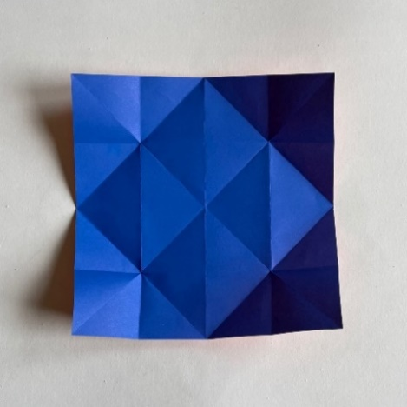
Step 13 – Fold the left-hand edge in to the centre vertical fold. Repeat with the right-hand edge.  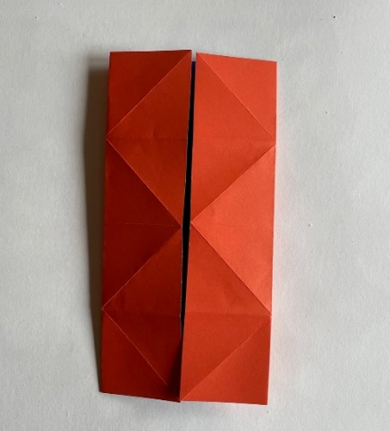 | Step 14 – Pull the paper down at the top left and top right, folding along the diagonals above the centre.  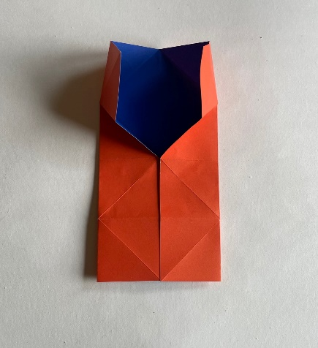 | Step 15 – Take the top edge and fold to meet the centre, making a house shape.  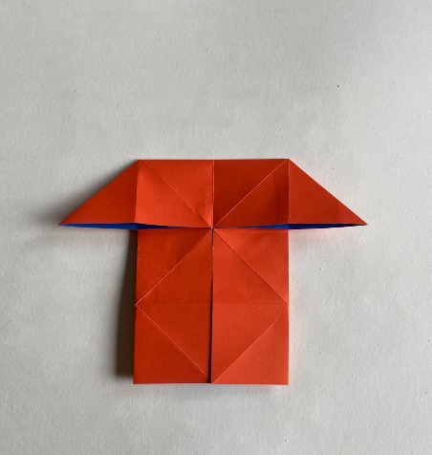
Step 16 – Repeat steps 14 and 15 for the bottom half of the paper.  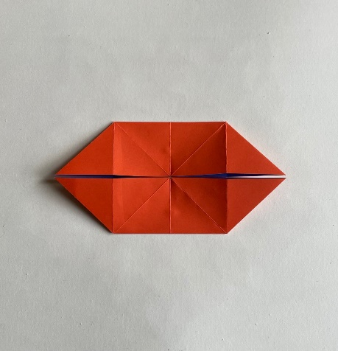 | Step 17 – Fold in half horizontally away from you, to make a boat shape which is open at the top.  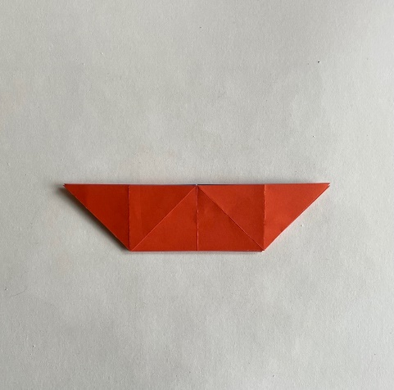 | Step 18 – Take the front right-hand point and bring down along the diagonal fold.  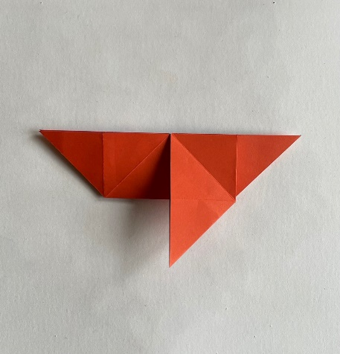
Step 19 – Repeat on the left-hand side.  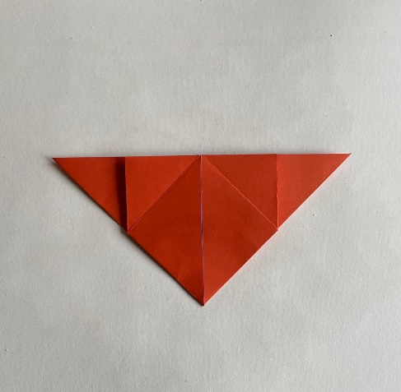 | Step 20 – Make a fold from point A to point B on the right side. Repeat on the left-hand side.  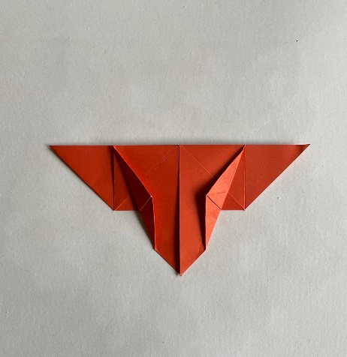 | Step 21 – Fold in half vertically towards you.  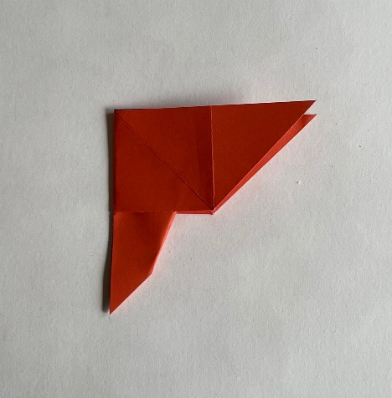
Step 22 – Make a fold from point C to point D. Fold forwards and backwards.  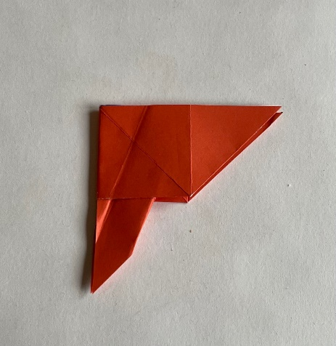 | Step 23 – Open up with the V-shaped mountain to the front.  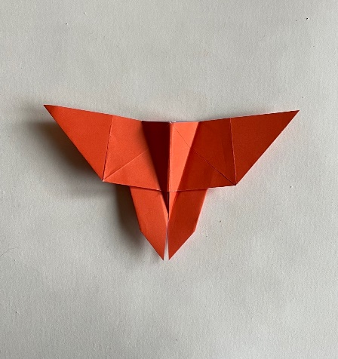 | Step 24 – Pinch the V-shaped body together, you now have a lovely origami butterfly!  