Volume and Surface Area of Spheres

Find the volume and surface area of these spheres.
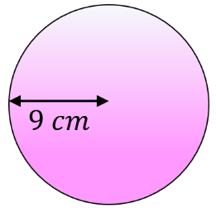
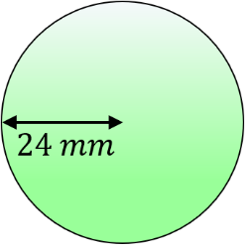
(a) (b)

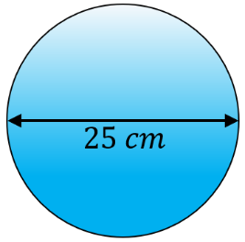
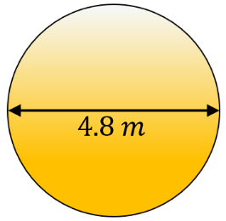
(c) (d)

Find the volume and total surface area of these hemispheres.
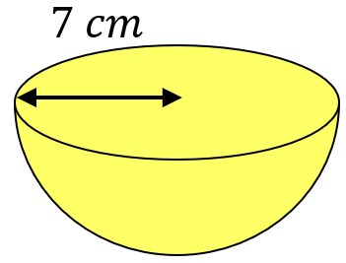
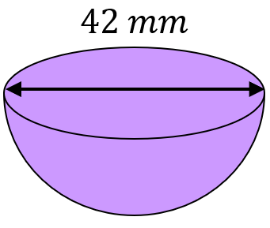
(a) (b)

Find the missing lengths.
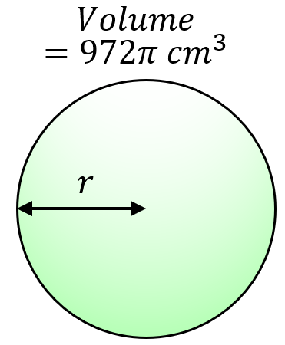
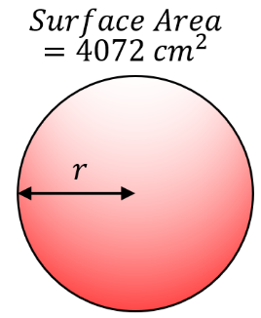
(a) (b)

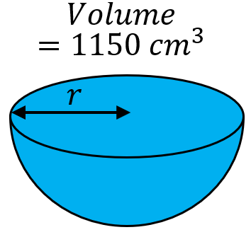
(c)

A container is made up of a hemisphere on top of a cylinder, both with the radius 26 cm. The total volume of the container is $230 000 {cm}^{3}$. Find the height of the cylinder.
Volume and Surface Area of Spheres

Find the volume and surface area of these spheres.
(a) (b)

(c) (d)

Find the volume and total surface area of these hemispheres.
(a) (b)

Find the missing lengths.
(a) (b)

(c)

A container is made up of a hemisphere on top of a cylinder, both with the radius 26 cm. The total volume of the container is $230 000 {cm}^{3}$. Find the height of the cylinder.

