Fill in the Blanks | Graphical Inequalities and Regions

$f(x)$ and $g(x)$ | Sketch of  $y=f(x)$  and $y=g(x)$ | Coordinates of intersection(s) | Solutions to  $f\left(x\right)≥g(x)$ | Shade the region given by:
$$f\left(x\right)=3x+1$$  $$g\left(x\right)=5-x$$ | 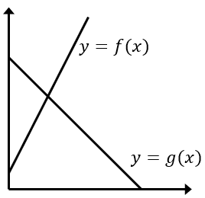 |  |  | $$y≥3x+1$$  $$y≤5-x$$  and  $$x≥0$$
$$f\left(x\right)=2x-\frac{1}{2}$$  $$g\left(x\right)=\frac{1}{3}x+2$$ |  |  |  | $$y≥2x-\frac{1}{2}$$  $$y≤\frac{1}{3}x+2$$  $$x≥0$$  and  $$y≥0$$
$$f\left(x\right)=x^{2}$$  $$g\left(x\right)=x+6$$ | 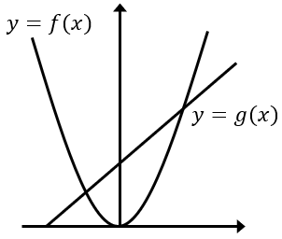 |  |  | $$y≥x^{2}$$  and  $$y≤x+6$$
$$f\left(x\right)=1-x^{2}$$  $$g\left(x\right)=x-1$$ |  |  |  | $$y≤1-x^{2}$$  and  $$y≤x-1$$
$$f\left(x\right)=4-2x$$  $$g\left(x\right)=x^{2}+x-6$$ |  |  |  | $$y≤4-2x$$  and  $$y≤x^{2}+x-6$$
$$f\left(x\right)=4-x^{2}$$  $$g\left(x\right)=2x^{2}+4x$$ |  |  |  | $$y≤4-x^{2}$$  and  $$y≥2x^{2}+4x$$

