Experimental and Theoretical Probability – Dice Differences
(a) | (b)
Roll two dice. Find the difference between the two numbers shown. Repeat the experiment 60 times, tallying and totalling the results. | Show your information as a graph.
 | 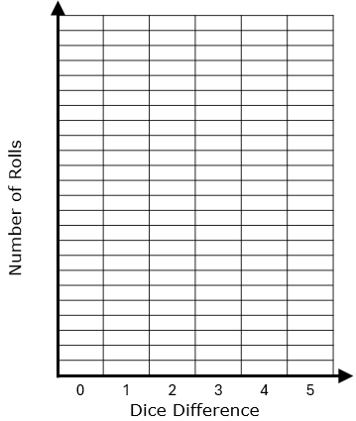
Dice Difference | Tally | Total
$$0$$
$$1$$
$$2$$
$$3$$
$$4$$
$$5$$

(c) | (d)
Complete the sample space to show all possible dice differences. | Calculate the experimental and theoretical probabilities for different outcomes. Give your answers to 3 decimal places.
$$1$$ $$2$$ $$3$$ $$4$$ $$5$$ $$6$$  $$1$$  $$2$$  $$3$$  $$4$$  $$5$$  $$6$$ | Outcome Experimental Probability Theoretical Probability  $$2$$  $$0$$  $$5$$  $$1$$  $3$ or $4$  Less than $2$
(e)
Compare the experimental and theoretical probabilities. What do you notice?

