Multi-Step Trigonometry Problems

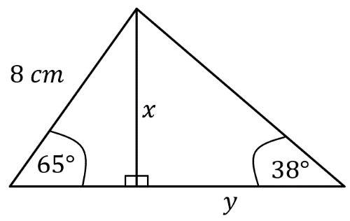
Find the missing lengths and angles in these diagrams.
(a)

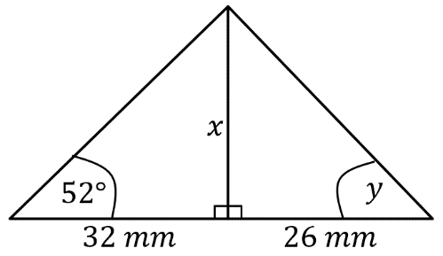
(b)

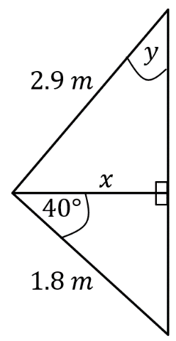
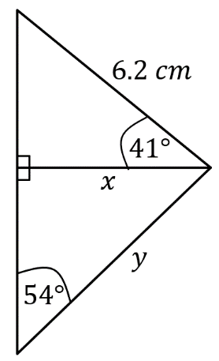
(c) (d)

A vertical mast is held in position by two cables of lengths 34 m and 42m, as shown in the diagram.
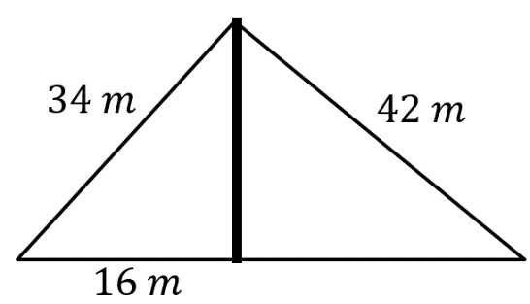

(a) Calculate the height of the mast
(b) Calculate the angle the horizontal makes with the 34 m cable.
(c) Calculate the horizontal distance from the foot of the mast to the 42 m cable.

Multi-Step Trigonometry Problems

Find the missing lengths and angles in these diagrams.
(a)

(b)

(c) (d)

A vertical mast is held in position by two cables of lengths 34 m and 42m, as shown in the diagram.

(a) Calculate the height of the mast
(b) Calculate the angle the horizontal makes with the 34 m cable.
(c) Calculate the horizontal distance from the foot of the mast to the 42 m cable.

